Prediction of Mutation in Virus DNA Using Multiheaded Attention

By
Sadhana Thirumangai Kalidoss, Harissh Ragav,
Gauri Lekshmi Sathya, Nimisha M Iyer, Shravan Sunil, Karthik M

Smart India Hackathon 2023

The ongoing evolution of viruses poses a significant challenge to public health, necessitating the development of predictive models to predict genetic mutations in virus DNA. This pitch presents a novel approach to predicting mutations in virus DNA sequences through the utilization of Multiheaded Attention, a deep learning mechanism originally designed for natural language processing tasks. By adapting this architecture to the genomics domain, we aim to enhance our ability to forecast viral mutation events accurately and use it to our advantage.

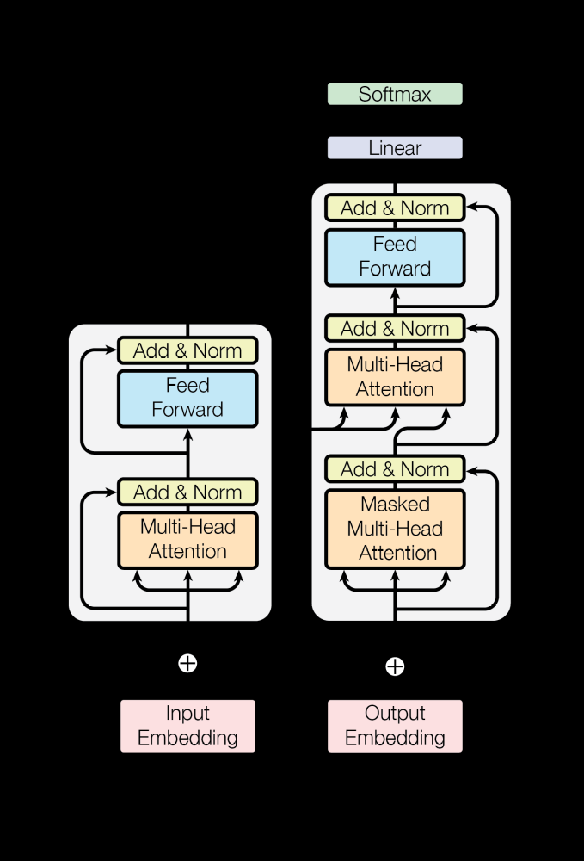
The transformer-model architecture

As Multiheaded Attention was originally a deep learning mechanism employed in natural language processing, we can use the same mechanism to identify the sequence of a gene code and use it to predict the same. As a result, we receive potential mutations and variants that will evolve from our virus shortly. Just as our neural network approaches a piece of literature, it approaches long genetic codes belonging to viruses. It is able to synthesize new genetic code which falls in line with natural evolution, allowing us to effectively predict what we may be facing with that virus.

By utilizing positional encoding, we eliminate the necessity of taking up the embeddings sequentially, which saves us a great deal of time when training the neural network. By introducing a new set of vectors which contain the positional information with the embeddings, we are able to sustain a more efficient method. Since the neural network is being fed genome sequences of viruses, we split the genome code into its constituent codons instead of using the sequence of nucleotides directly.
With accurate predictions of mutants, we can collect genetic information about the viruses which currently affect us on a large scale. As an example, we have taken the COVID-19 virus and have synthesized its potential mutations. We found SARS-COVID 2 to be the best option here as it has RNA. The rate of mutation for an RNA virus is greater than that of a DNA virus, which proves the threat of new strains prevalent. We may use this data to help us understand the genetic sequence of viruses themselves and in developing vaccines or drugs.

A well-known approach, known as ‘reverse vaccinology,’ uses the genome sequences of viral, bacterial or parasitic pathogens of interest rather than the cells as starting material for the identification of novel antigens, whose activity should be subsequently confirmed by experimental biology. In general, the aim is the identification of genes potentially encoding pathogenicity factors and secreted or membrane-associated proteins. Specific algorithms suitable for the in-silico identification of novel surface-exposed and, thus, antibody-accessible proteins mediating a protective response are used.

Genome sequence data also helps in the development of structural genomics. Structural genomics will help us solve and provide high-quality structures of macromolecules that are encoded in genomes. This complete understanding of macromolecules will facilitate the rational design of drugs and vaccines. It has already been used in the design of important chemotherapeutics such as HIV or influenza drugs.

With the recent development of genomics, the combination of the in-silico analysis of genome sequences, a procedure known as 'genome mining', and the knowledge from functional and structural genomics provide novel strategies for a more rapid identification of antigens leading to a third-generation of vaccines.

Vaccines remain one of our most important and cost-effective solutions to disease. By developing a neural network to predict mutations of a virus, we contribute to genomics, which provides us with an incredible opportunity in vaccine development where the traditional methods have failed. Keeping the evolution of structural genomics in mind, genes now have the potential to be a vital tool in the development of vaccines in the future. This software allows us to explore and research in a vast, undiscovered field.

Bibliography

A. Vaswani et al., “Attention is all you need,” arXiv (Cornell University), Jun. 2017, doi: 10.48550/arxiv.1706.03762.

L. Zhang, D. Lu, X. Bi, K. Zhao, G. Yu, and Q. Na, “Predicting disease genes based on multi-head attention fusion,” BMC Bioinformatics, vol. 24, no. 1, Apr. 2023, doi: 10.1186/s12859-023-05285-1.

S. Bambini and R. Rappuoli, “The use of genomics in microbial vaccine development,” Drug Discovery Today, vol. 14, no. 5–6, pp. 252–260, Mar. 2009, doi: 10.1016/j.drudis.2008.12.007.

Y. Shulgina and S. R. Eddy, “Codetta: predicting the genetic code from nucleotide sequence,” Bioinformatics, vol. 39, no. 1, Dec. 2022, doi: 10.1093/bioinformatics/btac802.

M. Elez, L. Robert, and I. Matic, “Method for detecting and studying Genome-Wide mutations in single living cells in real time,” in Methods in molecular biology, 2018, pp. 29–39. doi: 10.1007/978-1-4939-7638-6_3.

M. A. Salama, A. E. Hassanien, and M. A. Ahmad, “The prediction of virus mutation using neural networks and rough set techniques,” Eurasip Journal on Bioinformatics and Systems Biology, vol. 2016, no. 1, May 2016, doi: 10.1186/s13637-016-0042-0.

